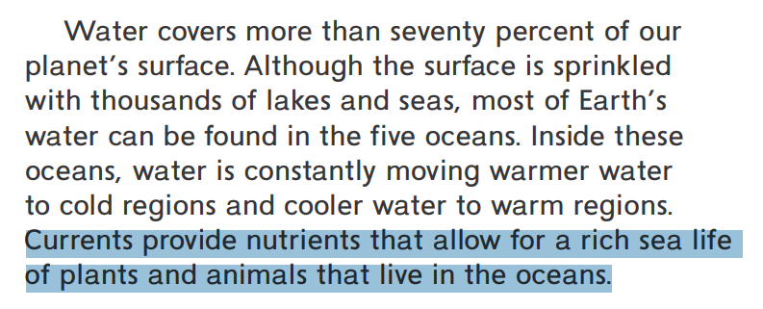
Cause and Effect:
Currents are the cause of something here. Underline the effect that currents cause.

This effect _____________________ in turn causes something else, circle what the effect in the sentence that the new cause creates.

How does the heading help us figure out the central theme?
__________________________________________________________
__________________________________________________________
What is the central theme or main idea of this section of text? Circle two details in the text below to support your central theme statement.
Central Theme:

_________________________________________________________

_________________________________________________________

_________________________________________________________

_________________________________________________________

