BACKGROUND

Many scientists believe that Africa was the first continent inhabited by humans. Early groups were hunters and gatherers living a mostly nomadic lifestyle. Small communities began to settle in areas with fertile land, good for growing crops. These communities began defending their land. From 1000 AD onwards, larger communities and kingdoms began to form. This party happened as a result of the Africans seeing a need to control the resources on their land from the traders coming from Europe and the Middle East. These traders came to barter for goods, slaves and gold. As leaders came and went the borders of these large communities and kingdoms changed. A large portion of northern Africa was formed under Islamic principles, while eastern Africa was formed under the principles of Christianity.
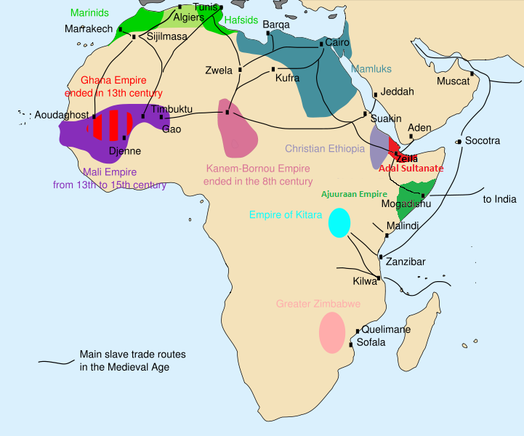
FAMILY STRUCTURE

A typical West African family included the father, mother, children, and close relatives all living in one household. Society expected everyone to be loyal to his or her extended family. Some areas also formed groups of men or groups of women who had been born around the same two or three year period. These groups formed special bonds in addition to their extended families. These loyalties helped villages work together.
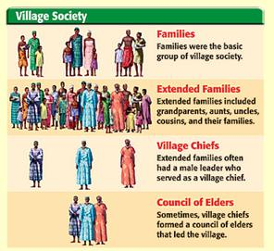
Every member had a specific job. The men hunted and farmed, usually millet and sorghum, which would be ground into flour and made into a thick paste or bread. Many farmers also raised goats and sheep. Like the men, West African women also worked very hard farming. They also collected firewood, ground the grain and carried water. Even the very young and old had their special roles. The older family members would teach the young ones the history, values, and traditions (songs, dances, and stories) of their family and society. Children began working as soon as they were able.

ECONOMY

The economy, or way people make a living, in each of these kingdoms had similarities and differences. The kingdom of Ghana in the west (830-1235 AD), traded in gold, salt, and copper. This made Ghana a rich and prosperous kingdom with an army of over 200,000 men. The kingdom of Mali (1230-1600 AD) covered most of North-east Africa and had created and organized trade system with gold dust and vegetables being exported to the North, while gold, salt and copper were traded. Mali also used cowrie shells as a form of currency. As Mali grew weaker the kingdom of Songhai (1464-1591 AD) grew stronger. Songhai also developed a system of currency in addition to a well-organized system of government. Songhai became more than just a place of trade, but also had cities known for their education, medicine, and arts and technology.

GROWTH

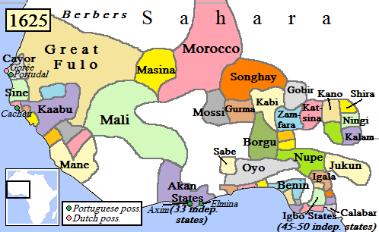
As trade increased in Africa so did the wealth and size of its kingdoms. Many of these kingdoms overlapped in their rule as a result of disputed lands. The cities of Gao, Timbuktu, and Jenne (located in the current country of Mali) became important educational and trade centers, known for their libraries and universities. As the Songhai Empire grew it became hard to govern and was ultimately defeated. As a result this large kingdom was split into many smaller ones. While forms

of slavery existed in Africa (punishment for unpaid debt, crime, or prisoner of war) before Europeans arrived it was very different from what was to come later.

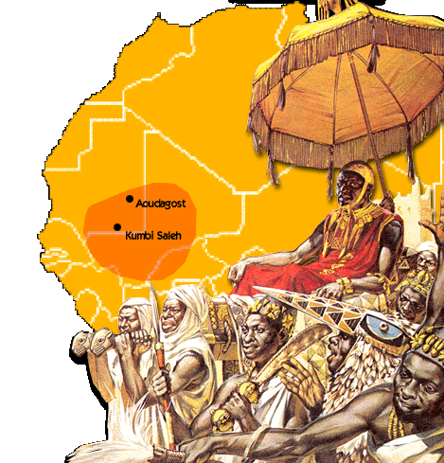

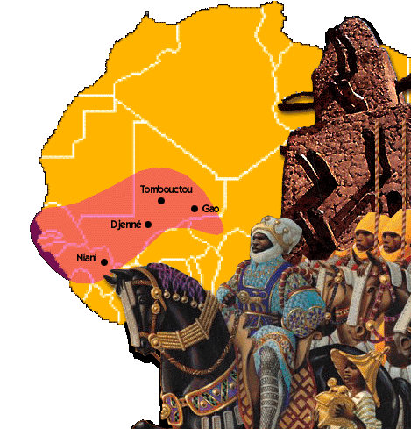
The Kingdom of Ghana

The Kingdom of Mali
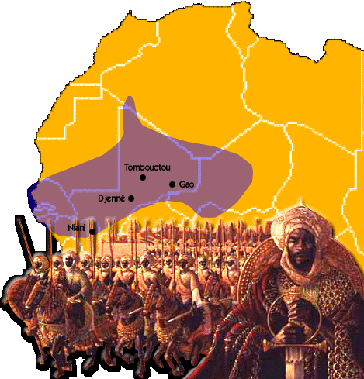

The Kingdom of Songhai

