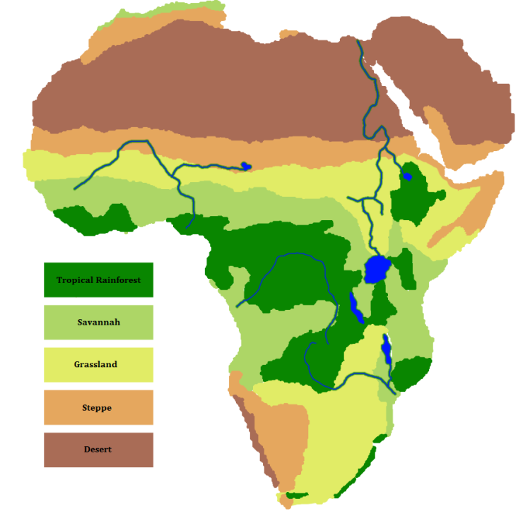
AFRICA

Africa is the second largest continent, about three times the size of the United States. The northeast corner of Africa is connected to the Middle East region of Asia. While Europe is located directly north of Africa they are not connected at any location. Africa is bordered by the Atlantic Ocean to the west, the Indian Ocean to the north, and the Mediterranean Sea to the north. Africa is currently made up of 55 separate countries. Africa contains both the world’s largest desert (the Sahara) and longest river (the Nile).

Victoria Falls, one of the Seven Wonders of the World is located in Africa.

GEOGRAPHY

The Atlas Mountain range runs across the northern edge of the continent (Morocco, Algeria and Tunisia). The highest point in Africa is Mt. Kilimanjaro at 19,340 ft. (Tanzania). The lowest point is Lake Assal (Djibouti) at 509 ft. below sea level. In addition to the Nile, Africa has several other important rivers including the Congo, Niger and Zambezi. The world’s second largest (by area) fresh water lake, Lake Victoria, is also located in Africa. *In case you are wondering, our very own Lake Superior is number 1.
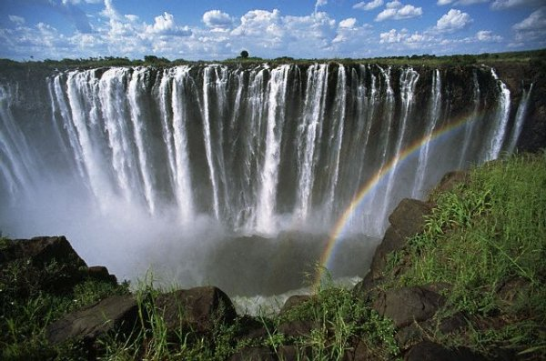
CLIMATE

Due to the large size of Africa, it is the location of many different biomes (climate zones). The five largest are: Tropical Rainforest, Savannah, Grasslands, Steppe, and Desert. Each of these climate zones has extreme temperature and precipitation differences. In the desert biome temperatures can get as high as 136°F, with as little as 50mm (about 2 in.) of rainfall per year. The tropical rainforest can see as much as 4,000mm (about 157 in.) of rainfall per year. A process known as desertification or the advancing of the desert is thought to be causing the loss of rich forestland at a rate of 600 meters per year.

WILDLIFE

With all of these different climate zones, the wildlife also varies across Africa. The lakes, rivers and seas of Africa offer a rich variety or marine life. From the camels of the northern desert to the penguins of the south and all of the species of the rainforests and grassland in between, Africa’s has a rich and diverse wildlife population.

