What is the central theme or main idea of this section of text? Circle two details in the text below to support your central theme statement.
Central Theme:

_________________________________________________________

_________________________________________________________

_________________________________________________________

_________________________________________________________

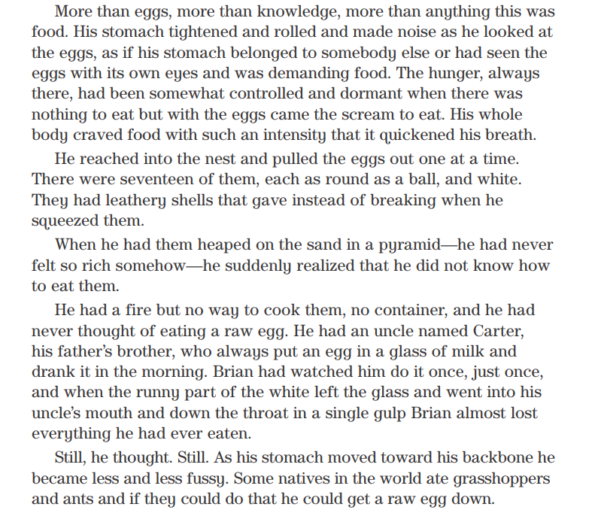
Sequence: Place these events in the order they happened on pages 111- 113.
Brian ate six eggs.
Brian made a plan to eat one egg a day and store the others.
Brian poked a hole in a turtle egg.
First,
Next,
Finally,

Look at the description of the turtle egg, then compare and contrast it to a chicken egg.
Chicken Egg | Similarities | Turtle Egg

