What is the central theme or main idea of this section of text? Circle two details in the text below to support your central theme statement.
Central Theme:

_________________________________________________________

_________________________________________________________

_________________________________________________________

_________________________________________________________

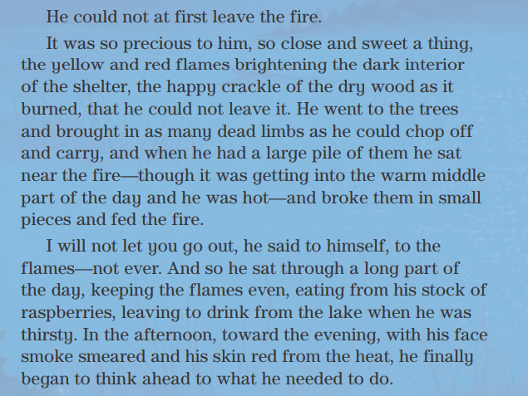

Sequence: Place these events in the order they happened on page 109.
An animal went to a pile of sand.
The animal went back to the water.
An animal moved from the water.
First,
Next,
Finally,

