Excerpt from “The House That Baba Built”

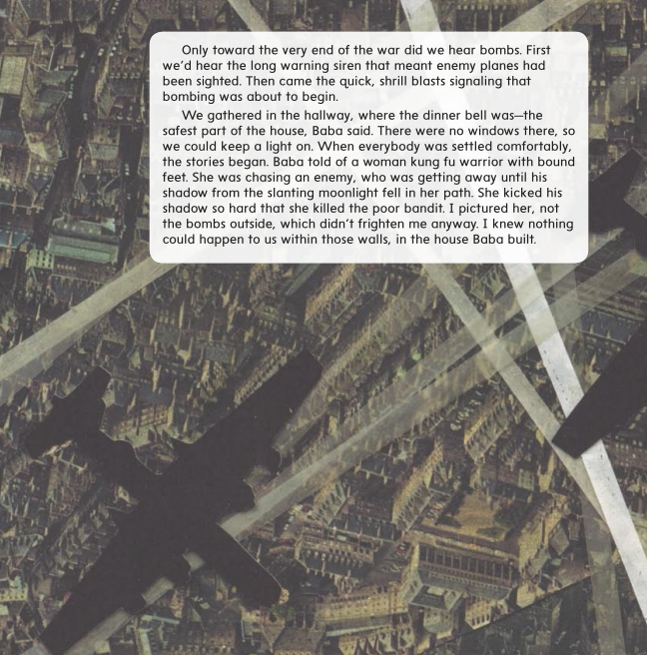

Excerpt from “My Librarian Is a Camel”

