Dirt Day 4 Comprehension
1. Why does the author describe soil’s surface as a “battleground”? RACE Restate the question, Answer, Cite evidence, Explain. Circle the evidence in the text below, then write it and put quotes around the direct statement.
The author describes soil’s surface as a “battle ground” because ____________
________________________________________________________________
_________________________________________________________________
According to the text,________________________________________________
_________________________________________________________________
_________________________________________________________________
This shows ________________________________________________________
_________________________________________________________________
_________________________________________________________________

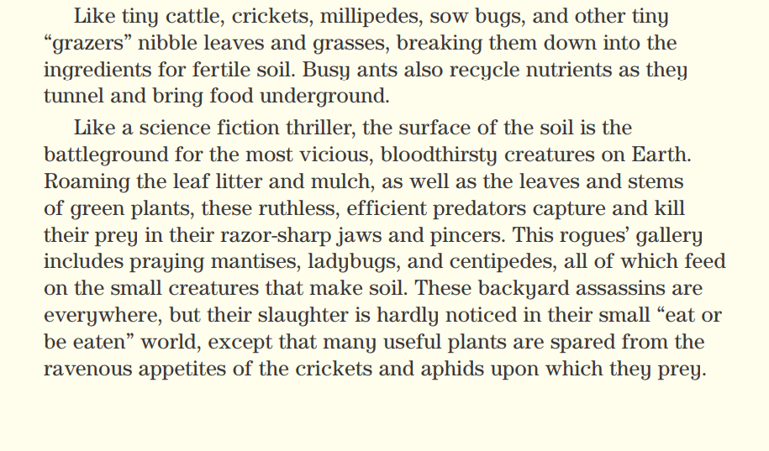
2. Explain why humus in soil is important for plants. Restate the statement, Answer, Cite evidence, Explain. Circle the evidence in the text below, then write it and put quotes around the direct statement.
The author describes soil’s surface as a “battle ground” because ____________
________________________________________________________________
_________________________________________________________________
According to the text,________________________________________________
_________________________________________________________________
_________________________________________________________________
This shows ________________________________________________________
_________________________________________________________________
_________________________________________________________________

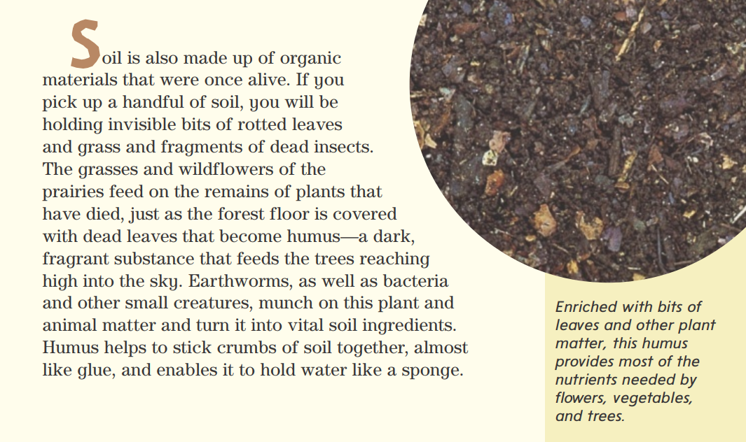

3. Compare and contrast how “A Handful of Dirt” and “Salmon Creek” each show that death in nature supports new life. You may use the text below to refresh your memories.
The two stories are similar because they both _____________________________
__________________________________________________________________
__________________________________________________________________
However, in a “A Handful of Dirt”, _____________________________________
__________________________________________________________________
__________________________________________________________________
__________________________________________________________________
In contrast, in “Salmon Creek” _________________________________________
_________________________________________________________________
_________________________________________________________________
_________________________________________________________________
_________________________________________________________________

