Dirt Day 3 Comprehension
1. Why should we stay away from mushrooms in the wild? Quote details from the text to support your answer. RACE Restate the question, Answer, Cite evidence, Explain. Circle the evidence below, then write it with quotes around the direct statement.
People should stay away from ___________________________________
because _________________________________________________________
________________________________________________________________
_________________________________________________________________
According to the text,_________________________________________________
_________________________________________________________________
This shows ________________________________________________________
_________________________________________________________________
_________________________________________________________________

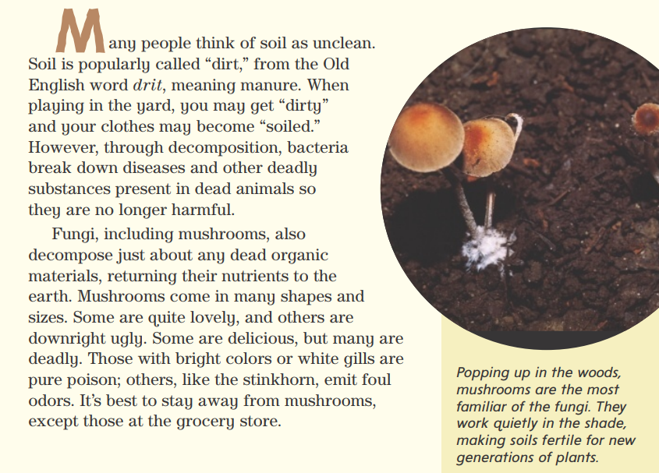
2. Explain how earthworms play an important role in healthy soil. Quote details from the text to support your answer. RACE Restate the question, Answer, Cite evidence, Explain. Circle the evidence in the text below, then write it and put quotes around the direct statement.
Earthworms ___________________________________________________
because _________________________________________________________
________________________________________________________________
_________________________________________________________________
According to the text, _______________________________________________
_________________________________________________________________
_________________________________________________________________
This shows ________________________________________________________
_________________________________________________________________
_________________________________________________________________

